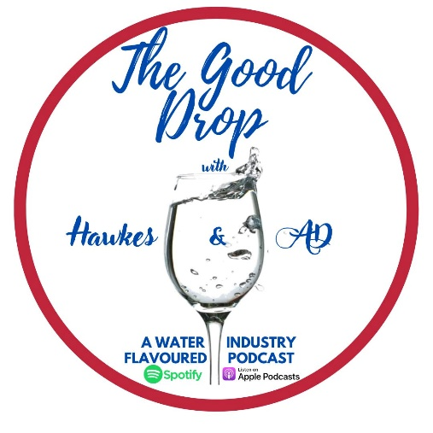
The Good Drop with Hawkes & AD – Interviewee Questionnaire
Interviewee Name:
Interviewee Position:

Interview Questions
- In your own words, tell us about yourself?

- Tell us how (or why) you got into your area of interest?

- What does a typical day look like?

- What motivates you?

- What would you like to get out of being on our podcast?

Fabulous 5 Questions
- What has been the greatest piece of advice received and who told you?’

- Who would you like to share a dinner with and why?

- What is your greatest non-work related achievement?

- Favourite place to travel and why?

- What is your go-to drink? - Red, white or other?

